**ASSIGNMENT 2**

**QUESTION:** Build a python code, Assume u get temperature and humidity values (generated with random function to a variable) and write a condition to continuously detect alarm in case of high temperature.

**CODE:**

import random

while(True):

temperature=random.randint(10,99)

humidity=random.randint(10,99)

print("Temperature:",temperature,"degree")

print("Humidity:",humidity,"%")

temperature_ref=37

humidity_ref=50

if temperature>temperature_ref and humidity<humidity_ref:

print("High temperature detected")

else:

print("Normal temperature")

break

**OUTPUT:**

**CASE 1:** WhenNormal Temperature detected

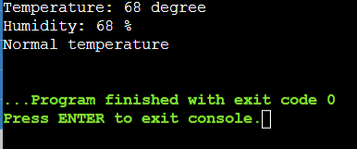

**CASE 2:** When high temperature detected

